DHCP (DYNAMIC HOST CONFIGURATION PROTOCOL)

**FOR ROUTER**

Router>enable

Router#

Router#configure terminal

Enter configuration commands, one per line. End with CNTL/Z.

Router(config)#interface GigabitEthernet0/0/0

Router(config-if)#ip address 192.168.10.1 255.255.255.0

Router(config-if)#ip address 192.168.10.1 255.255.255.0

Router(config-if)#no shutdown

Router(config-if)#exit

Router(config)#interface GigabitEthernet0/0/1

Router(config-if)#ip address 192.168.20.1 255.255.255.0

Router(config-if)#ip address 192.168.20.1 255.255.255.0

Router(config-if)#no shutdown

Router(config-if)#ex

Router(config)#int gig0/0/0

Router(config-if)#ip helper-address 192.168.20.2

Router(config-if)#ex

Router(config)#

FOR SERVER

1.

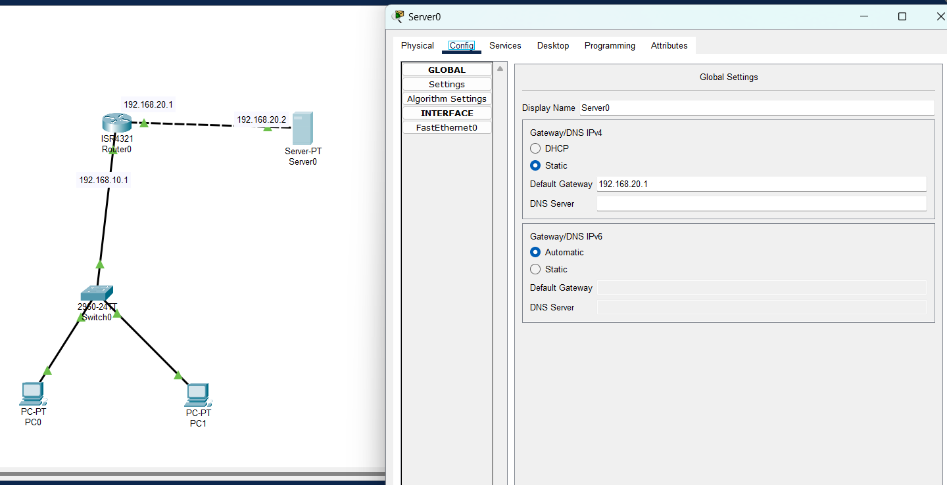

2

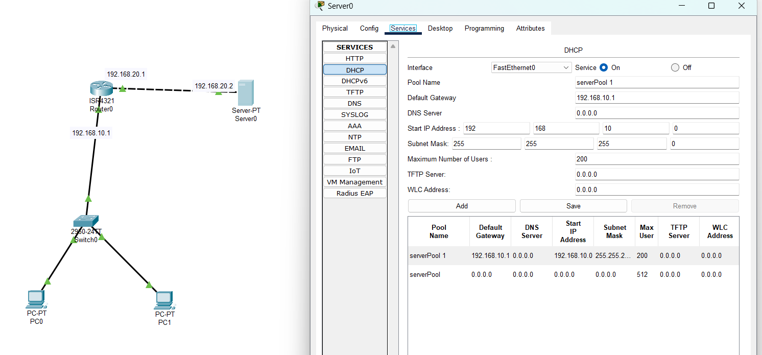

3

